

AMERICAN INTERNATIONAL UNIVERSITY–BANGLADESH (AIUB)
Dept. of Computer Science
Faculty of Science and Technology
CSC 2210: OBJECT ORIENTED PROGRAMMING 2
Fall 2025-2026
Section: AA
Group No: 3

Project Report On
Gaming Zone Management System
Supervised By
WAHIDUL ALAM RIYAD

Submitted By:
Name | ID
1.Bappi, MD. Ahsan Ullah | 22-49749-3
2.Mohammad Yasin | 23-51400-1
3.Ashari, Md. Abu Musa Al | 17-33225-1
4.Istiak Ahmed Sunny | 23-52401-2

CO2: Display and verify the mean of a real-life Project using the concepts of C# Graphical User Interface based environment with database integration to depict a desktop-based application.
Assessment  Criteria | Not Attended/ Incorrect (0) | Inadequate  (1-2) | Average  (3) | Good  (4) | Excellent  (5)
Evaluation Criteria | Evaluation Definition |  |  |  | Total =
Requirement fulfillment | Properly demonstrate a real-life scenario-based project with proper functional requirement identification for the Object-Oriented Programming project development activities.
Validation | Ensuring the ability of students’ proper demonstration on validation forms in their system in terms of dealing with the data.
Verification | Identifying if the students can verify the system data along with proper functional requirements in terms of data flow.

Table of Contents

1. INTRODUCTION 3
2. FEATURE LIST 4
2.1 User 1 4
2.2 User 2 4
2.3 User 3 4
3. ER DIAGRAM 5
3.1 Normalization 5
3.2 Finalization 5
4. UML DIAGRAM 6
4.1 Use Case Diagram 6
4.2 Activity Diagram. 6
5. CONCLUSION 7

INTRODUCTION

The Gaming Zone Management System is an interactive software system designed to manage and organize multiple gaming zones within a single platform. The system consists of six distinct gaming zones, where each zone represents a specific category of games such as Kids Zone, Racing Zone, AR/VR Zone, Bowling Zone, War Zone, and Arcade Zone.
The primary goal of this system is to provide users with a smooth, user-friendly experience for browsing, selecting, and downloading games from different zones.

The system allows users to explore various gaming zones and view all available games within a selected zone. Users can select one or multiple games across different zones without any limitation. All selected games are added to a selection list, which can be reviewed before proceeding. This ensures flexibility and convenience in game selection.

After completing the game selection process, the system displays a summary page showing all chosen games. Upon confirmation, users are required to log in or register to continue. New users can create an account through the registration process, while existing users can log in using their credentials. Once authenticated, users are granted access to their selected games and can enter the gaming zones to play.

Overall, the Gaming Zone Management System improves game organization, user interaction, and access control, making it efficient for both users and system administrators.

FEATURE LIST

User 1 Admin Features

Admin login and authentication

Add (insert) new Games into the system

Delete Games that are no longer available

Update and edit Game details, including price modification

View employee dashboard

View customer dashboard

Monitor overall system activities and product status

User 2 Employee Features

Employee login and authentication

Add (insert) new Games into the system

Delete unavailable Games

View, Edit and update assigned product-related information

User 3 Public User Features

View available Games

View Game prices

Search and browse Games

Purchase Games through the system

Register and log in to the system (if required for purchasing)

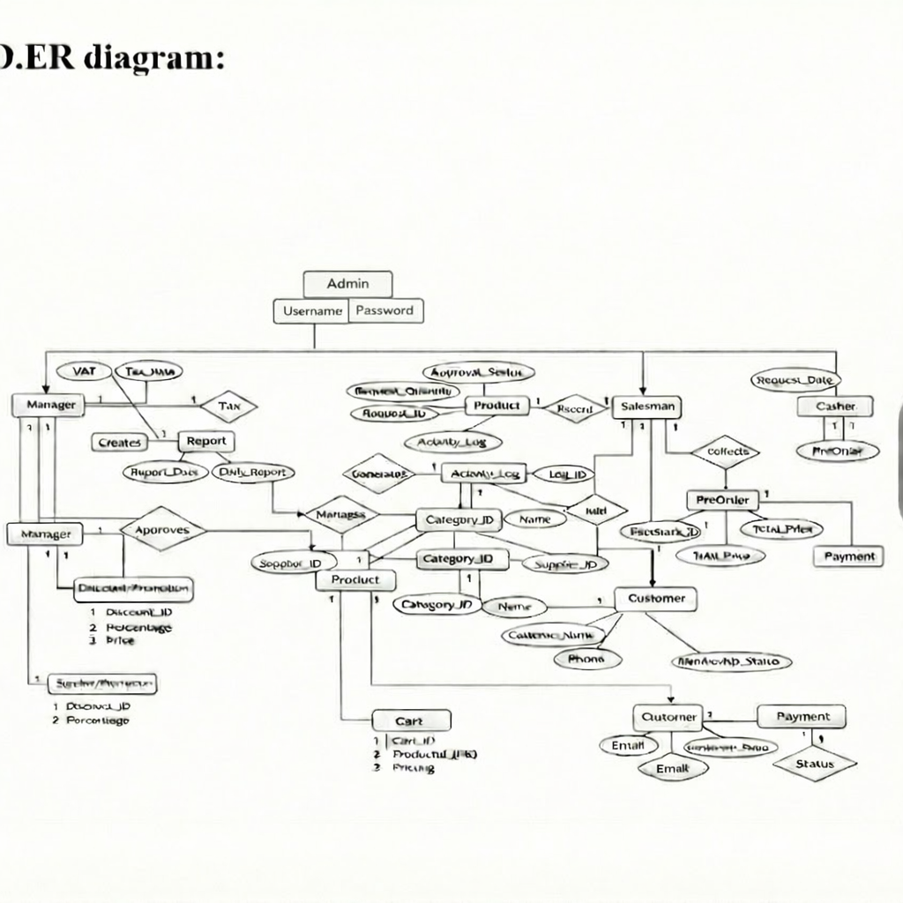

Fig 01: Entity relationship (ER) Diagram

Normalization
1NF Result

All entities in the system contain atomic attributes and unique primary keys. Therefore, the database satisfies First Normal Form (1NF).

2NF Result

Admin
Attribute Name | Description
AdminID (PK) | Unique identifier for admin
Username | Admin login username
Password | Admin login password
Role | Admin role
Attribute Name | Description
CustomerID (PK) | Unique identifier for customer
Name | Customer name
Phone | Customer phone number
Email | Customer email address
MembershipStatus | Membership status of customer

Attribute Name | Description
BookingID (PK) | Unique identifier for booking
CustomerID (FK) | References Customer(CustomerID)
ZoneID (FK) | References GameZone(ZoneID)

Attribute Name | Description
PaymentID (PK) | Unique identifier for payment
BookingID (FK) | References Booking(BookingID)

Finalization
The database has been successfully normalized up to Second Normal Form (2NF). All relations are in 1NF, and there are no partial dependencies present. This normalization ensures minimal redundancy, improved data consistency, and an efficient database structure suitable for the project implementation

Use Case Diagram
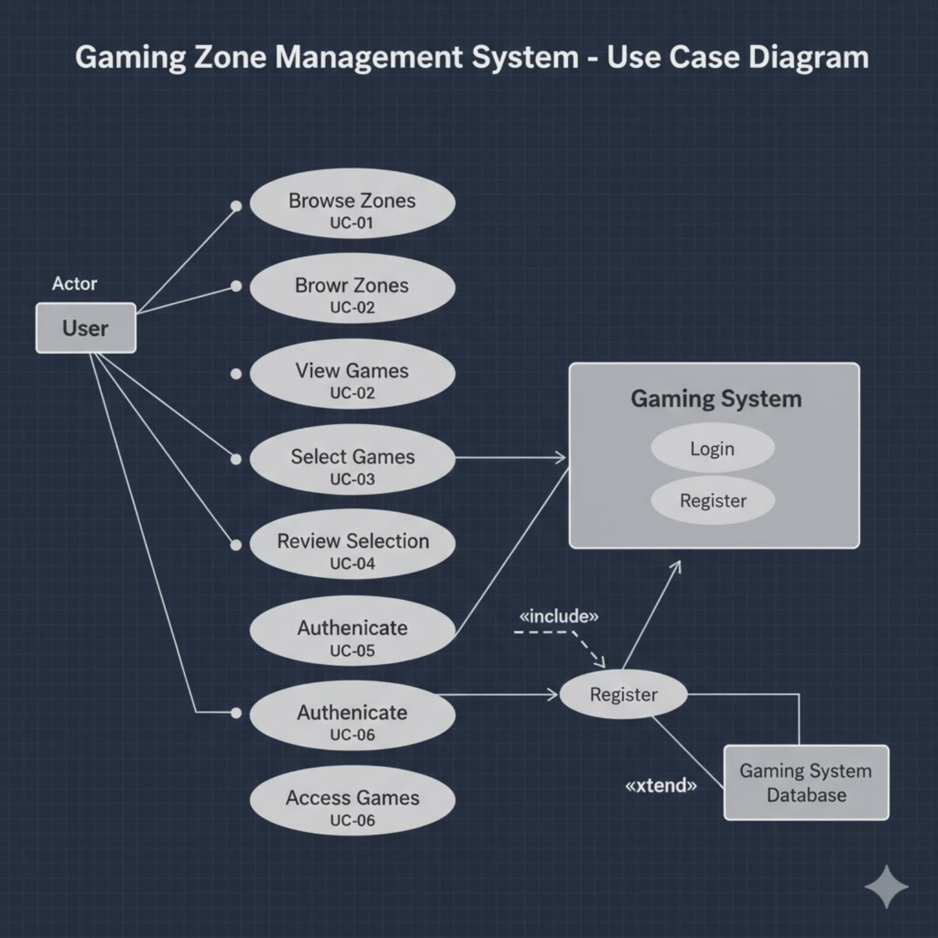

The Use Case Diagram illustrates the functional interactions between the User and the Gaming Zone Management System. It represents the services provided by the system and how the user accesses those services.

Actor
- User: Represents any customer who accesses the gaming zone system to browse zones, select games, and play games.

Use Cases Description

- Browse Zones (UC-01)
The user can browse available gaming zones such as Kids Zone, Racing Zone, VR Zone, Arcade Zone, etc. This allows the user to explore different categories of games offered by the system.
- Browse(View) Zones (UC-02)
After browsing, the user can view detailed information about a selected zone, including the games available in that zone.
- View Games (UC-02)
The system displays a list of games belonging to the selected zone. The user can see game names and relevant details.
- Select Games (UC-03)
The user can select one or multiple games from the displayed list. Each click adds the game to the selection list.
- Review Selection (UC-04)
Before proceeding, the user can review the selected games to confirm or modify the selection.
- Authenticate User (UC-05 / UC-06)
The system requires the user to authenticate by logging in or registering before accessing the selected games.
- Register
If the user does not have an account, they can register by providing required details. Registration information is stored in the Gaming System Database.
- Login
Registered users can log in using valid credentials to access their selected games.
- Access Games (UC-06)
After successful authentication, the user gains access to the selected games and can start playing.

System Components

- Gaming System: Handles login and registration processes.
- Gaming System Database: Stores user credentials, registration details, and game access data.

Activity Diagram.
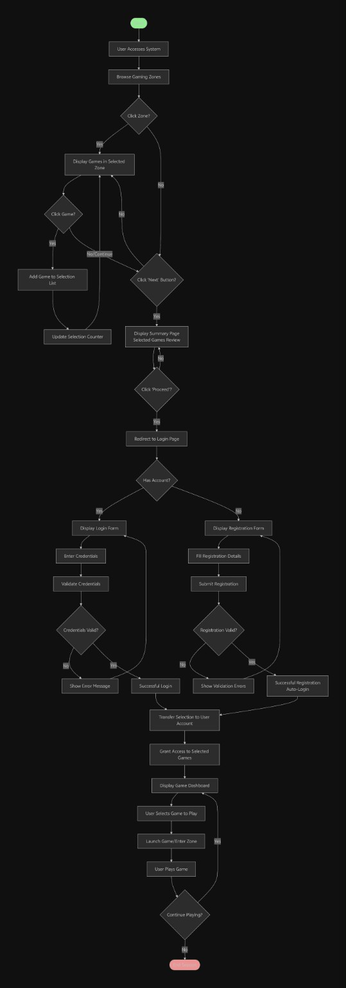

The Activity Diagram represents the step-by-step workflow of the Gaming Zone Management System, showing how the user interacts with the system from browsing zones to playing games.

Activity Flow Description

- User Accesses System
The activity begins when the user accesses the gaming zone system.
- Browse Gaming Zones
The user browses the available gaming zones displayed by the system.
- Select Zone
If the user clicks on a zone, the system displays the games available in that selected zone.
- Select Games
- The user clicks on a game to add it to the selection list.
- The system updates the selection counter.
- The user can continue selecting multiple games.
- Proceed to Next
When the user clicks the Next button, the system displays a summary page showing the selected games.
- Review Selected Games
The user reviews the selected games and decides whether to proceed or modify the selection.
- Authentication Process
- If the user clicks Proceed, the system redirects to the login page.
- If the user already has an account, they enter login credentials.
- If the user does not have an account, they complete the registration form.
- Validation
- Login credentials or registration details are validated.
- If invalid, error messages are shown.
- If valid, login or registration is successful.
- Transfer Game Selection
The selected games are linked to the user’s account after successful authentication.
- Grant Game Access
The system grants access to the selected games and displays the game dashboard.
- Play Game
The user selects a game, enters the gaming zone, and completes the payment if required.
- End Process
The process ends when the user finishes playing or chooses not to continue.

CONCLUSION
The Gaming Zone Management System is a complete solution for managing a multi-zone gaming facility. It improves operational efficiency, reduces manual errors, and enhances customer satisfaction. By using C# and database integration, the system ensures secure data handling, scalability, and real-time monitoring.

This project is suitable for real-world gaming zones and can be extended with features like online payment, mobile app integration, and AI-based game recommendations.

